February 2023  
Issue 2

***in this issue >>>***

*Adult Programs*

*Children’s Programs*

*Looking Ahead*

*Community Connections*

*Hours/Closings*

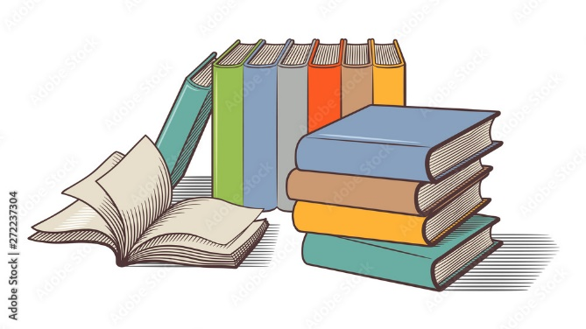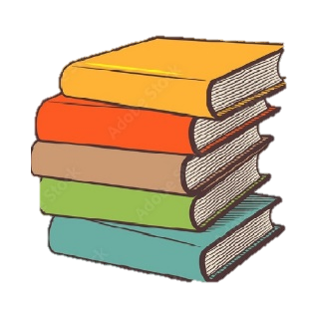

**Blind Date with a Book**

This month stop in and pick up your valentine’s date. Choose a wrapped book, check it out, and unwrap at home!

**Looking Ahead…**

**crafternoon project**  
2/2/23 – Alcohol Ink Votives

**Book club**  
2/16/23 – The invisible life of addie larue by V.E. Schwab

**Vita tax** (tax help)  
Beginning Feburary 2023  
Call 211 to schedule appointment (2/7, 2/14, 3/9)

**Crafternoon**

**new adult program!!!! 2/2, 2/9, 2/23, 3/2, 3/9, 3/16**Most Thursdays from 2pm-4pm. First Thursday of the month a craft will be provided by the library. Other weeks, bring a craft you are working on from home (knit, crochet, stamping, sewing, scrapbooking, etc)

**Birdhouse  
Contest**

We are excited to begin our annual bird house decorating contest. Beginning 2/17 stop in to pick up a bird house to decorate ($2 each). Bird houses are due 3/10/23. Voting begins 3/11/23. 5 votes/tickets for $1. There will be child and adult categories. Prizes for winners.

*Adult Programs*

**“Until I feared I would lose it, I never loved to read. One does not love breathing.”  
 -Harper Lee**

**Mayville Library**

*92 S. Erie St  
Mayville, NY 14757*

*716-753-7362*

*Web site: mayvillelibrary.com  
  
email:* [director@mayvillelibrary.com](mailto:director@mayvillelibrary.com)

*Facebook: Mayville Library*

*How to Contact Us:*

*between the*

***pages***

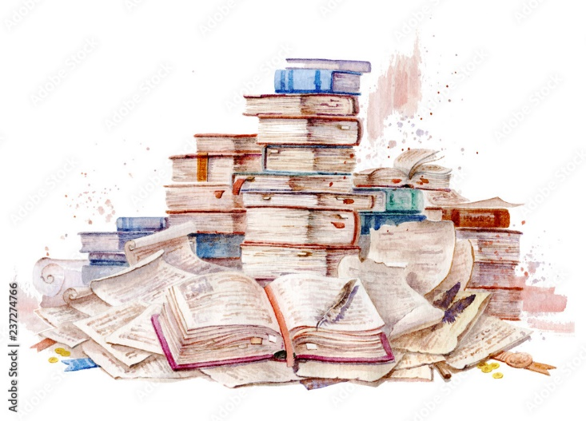

**Wee Wigglers**

Baby/Toddler/Pre-K Story Time

Wednesdays at 11am  
february – Music/dancing  
march – animals/dinosaurs  
April – Easter/spring  
lAST wED. MONTH – NURSERY rHYMES.

To sign up for our monthly newsletter email us at director@mayvillelibrary.com or stop in to sign up with an email address.

Limited print copies will be available at the library.

***Children’s Programs***

**Homeschool Group**

Wednesdays 11am-12:30pm  
2/1 Service Dog visit

2//8 fELTED sOAP W/ kIM w.  
2/15 Presidents  
2/22 Special Guest – whole grains

**Story Hour**

Pre-K/Elementary children  
Most Mondays 4pm-5pm  
2/6 polar bears/penguins  
2/13 valentine’s day  
2/20 library closed  
2/27 dr. seuss

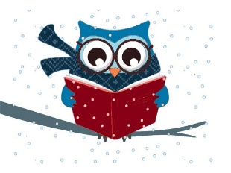

**Service Projects**

The homeschool group does monthly service projects to benefit the community.

This month they are collecting new baby items (blankets, toys, size 3+ diapers, formula, bibs, clothing, bath items, and bottles) for the Options Care Center in Jamestown, NY

library hours

Monday: 10am-7pm  
tuesday: 11am-5pm  
wednesday: 10am-5pm  
thursday: 11am-7pm  
friday: 11am-5pm

Saturday: 10am-1pm  
sunday: closed

library closed: February 20

**Library Cat: Bad Kitty**

Kids we need your help! Bad Kitty, our library cat, is getting into mischief! If you see her when you visit the library, let the staff know where she is and you will get a small prize! Remember – don’t touch Bad Kitty, she is still learning her library manners.

Community Connections

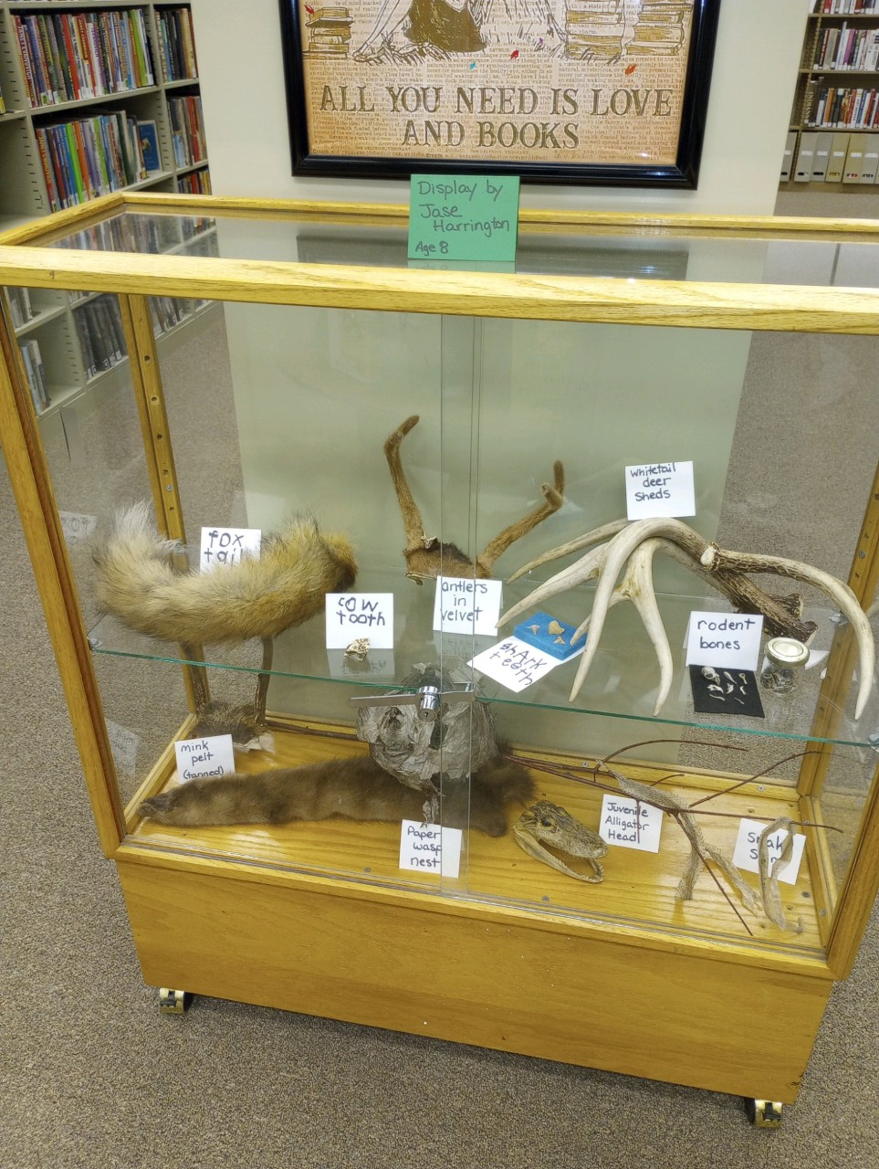

**New Activities & Classes**

Is there a new activity or class that you would like to see offered at the library? Can you teach a class? Let us know if there is something new you’d like to add to the programs and classes already offered.   
716-753-7362 or  
[director@mayvillelibrary.com](mailto:director@mayvillelibrary.com)

Teens or Tweens – What type of programming would you like to be offered here at the library?

**Library Book Sale**

The Library Book Sale runs from Friday, **February 17** to Saturday **February 25** during regular library hours. Pay by donation. We will have adult books, children’s books, DVDs, etc.

**Junior Fiction**Harry Potter and the Order of the Phoenix: The Illustrated Edition (Book 5) by J.K. Rowling  
The Door of No Return by Kwame Alexander  
Mummies in the Morning Graphic Novel (Magic Treehouse®)  
  
**DVDs**Till  
Lyle, Lyle, Crocodile  
Burnt

Masterpiece: All Creatures Great and Small Season 2

**JANUARY 2023 NEW ARRIVALS!**

**Adult Fiction**The House in the Pines:A Novel by Ana Reyes  
The Survivalist: A Novel by Kashana Cauley  
The Villa: A Novel by Rachel Hawkins  
All the Broken Places: A Novel by John Boyne  
  
**Biography**  
So Help Me God by Mike Pence  
Spare by Prince Harry The Duke of Sussex  
 **Picture Books**Winter Lullaby by Dianne White  
Bedtime for Bad Kitty by Nick Bruel  
How to Catch a Snowman by Adam Wallace  
  
**Young Adult Fiction**  
The Stolen Heir: A novel of Elfhame by Holly Black  
All My Rage: A Novel by Sabaa Tahir  
Odder by Katherine Applegate