May 2023  
Issue 5

***in this issue >>>***

*Adult Programs*

*Children’s Programs*

*Looking Ahead*

*Community Connections*

*Hours/Closings*

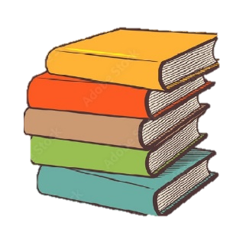

**Tuesday Club – 5/2/23 1:30pm**

In 1895 a group of area women formed a reading circle. They decided to call themselves the Tuesday Club (because they met the first Tuesday of each month) and in 1901 began taking steps to start a community library, which eventually became our beloved Mayville Library.  
 The Tuesday Club continues to meet the first Tuesday of each month, April-June & September -November. Ladies, if you are interested in finding out more about Tuesday Club, stop by and join us for guest speakers, luncheons, and more.

**Looking Ahead…**

**crafternoon project**  
5/4/23 – Clay w/ Annette

**Book club**  
5/18/23 – Killers of the flower moon by David Grann

**Book sale!**May 26th – may 30th

**Libby**

Borrow ebooks and audiobooks or transfer to Kindle with the library’s reading app.

If you have a CCLS library card you can use libby!! Ask library staff for more information.



*between the*

***pages***

**Crafternoon**

Stop in Thursdays from 2pm-4pm, bring a craft you are working on from home. First Thursday of the month the library will provide the craft.5/4, 5/11, 5/18, 5/25

*92 S. Erie St  
Mayville, NY 14757*

*716-753-7362*

*Web site: mayvillelibrary.com  
  
email:* [director@mayvillelibrary.com](mailto:director@mayvillelibrary.com)

*Facebook: Mayville Library*

*Adult Programs*

**“The only thing you absolutely have to know, is the location of the library .”   
 -Albert Einstein**

**Mayville Library**

*How to Contact Us:*

**Wee Wigglers**

Baby/Toddler/Pre-K Story Time

Wednesdays at 11am  
May – cars/boats/trains  
June – Program Break  
  
lAST wED. MONTH – NURSERY rHYMES.  
  
**No Wee Wigglers June 7-26th**

***Children’s Programs***

**Summer Reading**

“All Together Now” is the theme for Summer Reading program this year! Join us (most) Mondays **(6/26, 7/10. 7/17, 7/24, 7/31 and 8/7).** Elementary @ 10:30am or 4:00pm. Wee Wigglers (baby/toddler) @ 10:15am.

**Story Hour**

Pre-K/Elementary children  
Most Mondays 4pm-5pm  
5/1 Birds  
5/8 Mother’s Day   
5/15 Dinosaurs  
5/22 Memorial Day   
5/29 **library closed**

**Homeschool Group**

Wednesdays 11am-12:30pm  
5/3 Art/legos

5/10 Write your own story  
5/17 outside  
5/24 sharing  
5/31 year end party!!



**Homeschool Group Service Project**

This month the Homeschool Group is collecting supplies for the Mayville Food Pantry. Stop by the circulation desk for needs list.

library hours

Monday: 10am-7pm  
tuesday: 11am-5pm  
wednesday: 10am-5pm  
thursday: 11am-7pm  
friday: 11am-5pm

Saturday: 10am-1pm  
sunday: closed

library closed: May 29th

**Chololate!**

What goes better with books than chocolate?!?! The Mayville Library is selling candy to benefit our Children’s Programming. Candy is $1.50 each at the circulation desk.

To sign up for our monthly newsletter email us at director@mayvillelibrary.com or stop in to sign up with an email address.

Limited print copies will be available at the library.



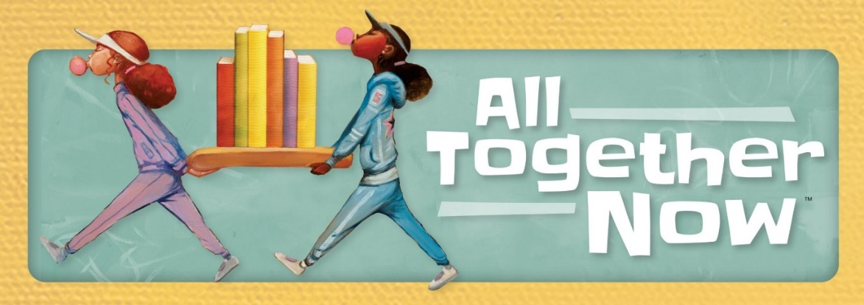

Community Connections

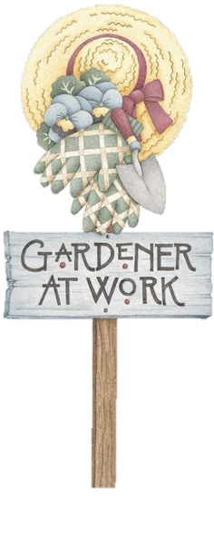

**Book Sale**

We will be holding a book sale Memorial Day weekend. Stop in and find some treasures. The sale will be held May 26th, 27th and 30th during regular library hours. Sale is by donation.

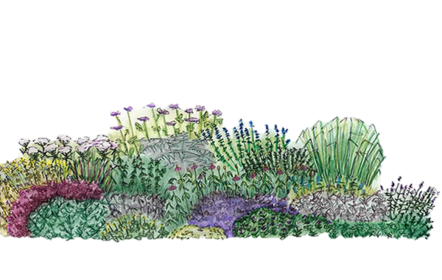



**April 2023 NEW ARRIVALS!**

**Adult Fiction**Strangers in the Night by Heather Webb Homecoming by Kate Morton Loyalty by Lisa Scottoline Hello Beautiful by Ann Napolitano  
Hang the Moon by Jeanette Walls  
  
**Adult Non-Fiction/Biography**  
Faith Still Moves Mountains by Harris Faulkner  
Go Back, You Forgot the Flowers by Adrienne Ploss **Children’s Fiction**Dog Man: Twenty Thousand Fleas Under the Sea by Dav Pilkey  
  
**2023 CLSC List**   
Damnation Spring by Ash Davidson  
The Ministry for the Future by Kim Stanley Robinson  
American Midnight by Adam Hochschild  
The Wild Fox of Yemen: Poems by Threa Almontaser  
Under the Skin by Linda Villarosa Dr. No by Percival Everett  
The Lincoln Highway by Amor Towles (coming soon)  
One Hundred Saturdays by Michael Frank

**Attention Gardeners!**

The Mayville Garden Club will be having its first two meetings on Thursday, May 4th and Thursday, May 11th, both at 6:00pm here at the library. Let’s get together and have some FUN! Come to the meetings and help make the garden club what YOU want it to be. Classes, projects, garden tours, plant exchanges, community service, and MORE!

There will also be a gardening class, **Blooms Year Round**, held on Monday, May 15th at 6pm, taught by a Master Gardener.

Is there a new activity or class that you would like to see offered at the library? Can you teach a class? Let us know if there is something new you’d like to add to the programs and classes already offered.   
716-753-7362 or  
[director@mayvillelibrary.com](mailto:director@mayvillelibrary.com)

Teens or Tweens – What type of programming would you like to see offered here at the library?

**Junior Fiction**  
Guinness World Records 2023  
Mystery in Rocky Mountain National Park   
by Aaron Johnson  
Discovery in Great Sand Dunes National Park   
by Aaron Johnson